August 28th, 2017

Welcome back Parkland Families and a warm welcome to those joining the Parkland Community!
I hope everyone in our community has had a restful summer break and is ready for an exciting new school year. I look forward to welcoming all our Parkland Panthers back to school and meeting everyone in our great community.

I’ll be sending out information as the week goes on updating families about the first week. In the meantime, here is some information to help you start to plan as you look ahead to next week.

The plan for the first week is as follows for all students in Grades 1 to 5. A separate Gradual Entry & Welcoming Conversation plan will be sent out to families who have students entering Kindergarten at Parkland as their schedule will be somewhat different. This Kindergarten schedule will be sent out in the next few days.

Tuesday, September 5
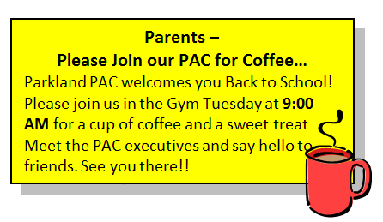
Students attend for 30 minutes (9:00 – 9:30) so that we can welcome them back and do an attendance check. For the remainder of the day staff will be involved in confirming attendance and working to finalize our classroom placements. Most students will meet in their classroom from last year with the following exceptions:
- Grade 1 – 5 students who are new to Parkland will meet in the office.
- New Kindergarten students will meet in the Library
- Grade 5 students will all meet in Room 38 (Mr. Steele’s classroom)
*Please see the map below if you are not sure of the room numbers.

Wednesday, September 6 – Friday, September 8
More information about where students will meet for the remainder of the week will be sent home with students and by email on Tuesday.

We have a number of activities planned for the first week of school to ensure that the time prior to being placed in their new classroom groupings is well used. We will be coming together frequently as a school community to welcome new students and teachers into our community, and to set school-wide expectations. During the week these school-wide activities will include:
- Canada’s 150th - Learning about Canadians who have made great contributions to our country
  - students will discuss the attributes of Canadians who have made a difference
  - goal-setting – students will consider how these great Canadians have set and met their goals.
- School Expectations – time will be spent discussing school-wide expectations and routines to ensure we collectively create a safe and secure learning community for everyone.

School Supplies
Starting on Wednesday, please have your child bring a pencil case with a few basic supplies for use this week. Please include a pencil, eraser, crayons, scissors, and a glue stick. Please keep all other supplies at home until students are in their permanent placement for the year.

Parkland Elementary is on Twitter
In addition to regular email messages and information posted to our website, Parkland Elementary is now on Twitter @parklandelem Check our page for regular updates as we get ready for the first week back and follow us throughout the school year for announcements and all things Parkland.
That’s it for now, enjoy the beautiful Coquitlam weather!

Chris Hunter, Principal, Parkland Elementary

